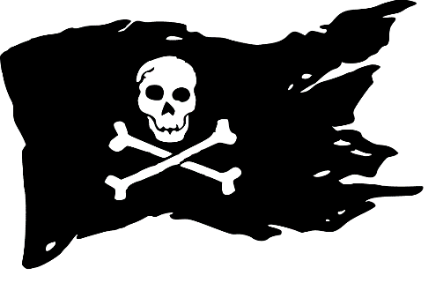**Event Name :**  DEATH RACE.

**Event Description:**

The game comprises of two levels. The first level is themed as FAST & FURIOUS and is basically a roboRace. The bot has to pass over different hurdles during the race and the time to reach the final checkpoint will be noted down . Any team may choose to skip a hurdle but there will be penalty for that.

Level 2 is Robowar . Each team must have minimum one weapon on its robot. Explosive weapons are not allowed. This level will be based on points .

The winner will be decided based on scores from both the levels.

**Score Structure** :

***Level 1:***

The maximum Time limit to complete the track is 3 mins . The scoring will be done in the following way : (3*60 seconds – Time taken by the Robot to complete the track(in sec)). Weapons are not allowed in this level.

***Level 2:***

This level will be Robo war. Both the teams will compete in a pit for 1.5 minutes .10 points will be scored when one robot hits the other robot . If a team disables the robot of the other team then 20 bonus points will be awarded. If a team is pushing another robot out of the pit then 20 points will be awarded.

***GRAND FINALE:***

Best teams (combined success in the above levels) will compete in real Death Race. Where two teams will race at the same time and points will be awarded for damaging the other bot while racing. In between the bots will have to cross a pit where they will have to fight for 1.5 minutes and then they can continue the race.

*Disclaimer:*

1) Judges and Referee decision is final and undebatable.

2) Organisers are not responsible for any damage of bots.

3) The teams must carry their own components.